## Document Overview

This document provides step-by-step instructions on how to launch the SCRM-Lite interactive page and SCRM tool in R 4.4.1. This provides more detailed information – with screenshots included – on how to visualize and reproduce the results in the SCRM-Lite and SCRM, respectively.

#### Know before you go

You will need to do several things before running these scripts in R.

1. If you have never used R, skip to step 2. **Existing R user:** Existing R users should ensure they have the latest version of R, RStudio, and RTools. As of this document being written in October 2024, this is version 4.4.1 “Race for Your Life.” A popup will usually appear upon launching RStudio if an update is required.
2. **New R user:**
   1. You need to install R and RStudio on your computer or laptop. These can be downloaded from this webpage: <https://posit.co/download/rstudio-desktop/>. Make sure you download the correct file based on the type of computer you have.

1. It is also highly recommended to download and install RTools 4.4 from <https://cran.r-project.org/bin/windows/Rtools/>

#### Accessing code from GitHub

1. In GitHub, locate and click on the green “< > Code” button. A new window will appear. Navigate to and click on “Download ZIP” to download a copy of all files in this repository.

1. Go to the Downloads folder of your computer or laptop and open the zip file.

1. Navigate through the folders until you see three folders: SCRM, SCRM-Lite, and Supplemental Materials.

1. Now you are ready to follow the below instructions to launch the SCRM-Lite interactive page and SCRM tool.

## SCRM Lite Tool

#### Instructions for running the SCRM Lite

1. First, you will need to open the SCRM-Lite.Rproj file from the SCRM-Lite folder of the zip file. Double-clicking this file will automatically launch RStudio.

1. Next, you will need to open the app.R file from the same folder. Double-clicking this file will open the file in RStudio

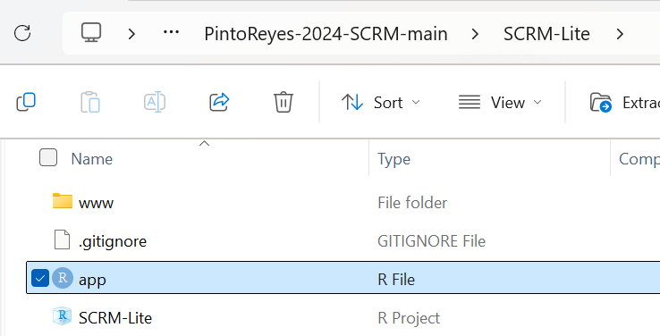

1. Now, you will see that the app.R file is loaded into RStudio containing the relevant code.

1. Click “Run App” in the top right corner of the code panel. (**Optional, but suggested**) Select “Run External” from the dropdown. Then click “Run App” to launch in your web browser.

1. A new popup window will launch the Shiny app. It should look like the below

1. By default, the high variability baseline scenario referenced in the manuscript is highlighted in green. You can move the sliding bars to see the results of the different scenarios described in our manuscript. The table in the README file on GitHub describes what combinations are available for the selections of the sliding bars, and the equivalent scenario described in the manuscript to. We have pasted this again here for your convenience:

**Contamination Event Variability options:** Low, High

**Additional Product Testing options:** None, Some

**Process Wash options:** Standard, Improved

The following selections in the SCRM-Lite tool match the scenarios in the manuscript:

| **SCRM-Lite Options** | **Manuscript Scenario** |
| --- | --- |
| High; None; Standard | High Variability, Baseline |
| High; Some, Standard | High Variability, Additional Product Testing |
| High; None; Improved | High Variability, Improved Process Controls |
| High; Some, Improved | N/A, combination of practices |
| Low; None; Standard | Low Variability, Baseline |
| Low; Some, Standard | Low Variability, Additional Product Testing |
| Low; None; Improved | Low Variability, Improved Process Controls |
| Low; Some, Improved | N/A, combination of practices |

1. This concludes the instructions for running the SCRM-Lite. Again, this is simply to visualize the results presented in the manuscript and allow the interested user to interact with the scenarios.

## SCRM Tool

#### Instructions for running the SCRM

**DISCLAIMER:** **The use of the SCRM Tool is currently only meant to reproduce the results presented in our manuscript**. This tool should **NOT** be used without consultation with an experienced risk assessor to run new scenarios for guiding food safety decision-making. While we understand our code is publicly available, we expect users to engage a risk assessor through their network who can help generate reasonable inputs before using the SCRM Tool. We welcome interactions with those who are interested in using this to aid risk management decisions in their fresh produce supply chain and need help getting started. You may contact the corresponding author, Matthew Stasiewicz at [mstasie@illinois.edu](mailto:mstasie@illinois.edu).

1. Navigate into the “SCRM” folder. In the folder, you will see two documents: SCRM-Shiny.Rproj and app-V1.1.R.

1. First, you will need to open the SCRM-Shiny.Rproj file from the Downloads folder of your computer or laptop. Double-clicking this file will automatically launch RStudio.
2. In the bottom-right panel of RStudio you will see other files in the folder under the “Files” tab, click “app-V1.1.R” to open it in RStudio.

Now, you will see that the app-V1.1.R file is loaded into RStudio containing the relevant code.

1. Click “Run App” in the top right corner of the code panel. (**Optional, but suggested**) Select “Run External” from the dropdown. Then click “Run App” to launch in your web browser.

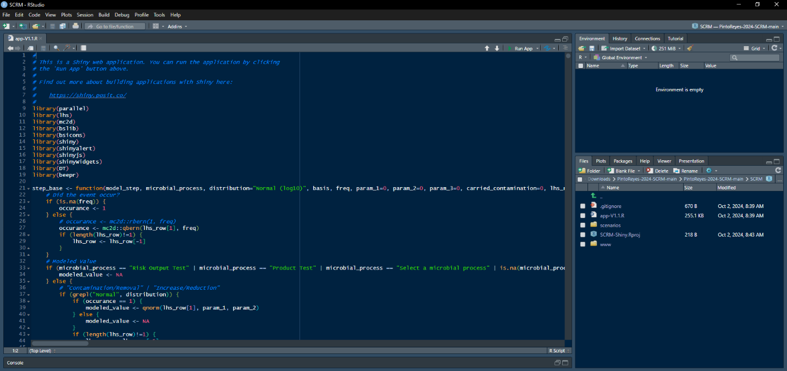

1. A new popup window will launch the Shiny app. It should look like the below

1. This app has 4 tabs: Models, Results Comparisons, User Guide, and Acknowledgements. **Before reading further instructions, we encourage the user to navigate to the User Guide tab to see an overview of the model, glossary of terms, and baseline scenario terminology.** The glossary provides definitions for all terms that appear in the model, and the baseline scenario terminology displays the relevant terms and their definitions for the baseline scenario.

#### Example: Running the Improved Process Controls - High Variability Scenario

1. Launch the SCRM app as per the instructions above.
2. In the “Preset Scenarios” panel on the lefthand side, click the dropdown arrow, scroll to select “Improved Process Controls” and click “Load Scenario” (button will turn dark green). This will auto-populate the model with the relevant parameters for Improved Process Controls under high variability. **Note:** the model defaults to the HIGH variability scenario. **The ReadMe file provides a detailed description of modifications needed to run low variability scenarios.**

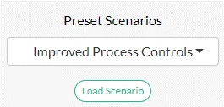

1. Click “Run” in the panel below (button will turn dark green). You can also select the “Beep?” checkbox if you would like the model to make a noise when it has completed running (**Note:** requires your computer volume to be unmuted).

1. A pop-up window will appear with an alert. Click “Continue”. This alert is simply because the preloaded scenario has the parametrized Consumer Handling stage loaded AFTER the risk output test (reference the manuscript for additional information.

1. Two pop-up windows will appear in the bottom right corner of the screen. The yellow pop-up notifies the user that a product test step has not been added or is disabled. This is an additional reminder to users who run the additional product testing scenario. The blue window notifies the user that the model is running, and time stamp for when the run began.

1. Once complete, the three results tables will be loaded. You can download the results as individual CSV files by hitting the “Download Results” button under any of the tables.
2. Or, if you want to run multiple scenarios from the manuscript, you can save these to slots.
   1. Select the desired slot number from the left panel

* 1. Click “Save to Slot” button. **Note:** if you are running several scenarios, **verify you are selecting a NEW slot number every time,** e.g., selecting 1 two times in a row will override the results from your first model run. Then you would need to rerun that scenario again and save to a different slot. We recommend saving to slots immediately after each run.

* 1. Navigate to the “Results Comparisons” tab at the top of the page

* + 1. Both the results for lot counts by risk category and regulatory testing counts will appear in two separate tables.
    2. You can download all results into a CSV file by hitting the “Download Table” button once you have completed running the scenarios.

1. This concludes the instructions for running the SCRM tool.